**Exercise 2: E-commerce Platform Search Function**

**Understanding Asymptotic notations:**

**Explain Big O notation and how it helps in analyzing algorithms**

In computer science the Big O notation is convenient in describing the amount of time or space required by an algorithm. The time/space complexities of an algorithm can be defined in terms of upper bound (using larger-O notation).

* Expresses the asymptotic behaviour of a function (or the order at which time or space scales with the size of the inputs), as opposed to its actual value.
* Can be used in order to find out the efficiency of different data structures or different algorithms.
* It provides an upper bound on the amount of time an algorithm may require depending upon the size of the input. The first one is that in order to find out the time order of an algorithm, the worst-case scenario will be considered as the key factor.
* This can be denoted as O(f(n)) where f(n) is a function that reports the number of operations (step) that an algorithm is going to require to solve a problem of size n.

**Analysis of Algorithms using Big-O**

* Big-O notation is a mathematical method to estimate and define the efficiency of an algorithm. This is established in the terms of **Time Complexity** and **Space Complexity**.
* Big-O understands how the algorithm performs for small vs large inputs.
* We can compare multiple algorithms using Big-O.
* Big-O ignores constants and lower-order terms.
* We can decide on what data structure easily.

**Linear Search:**

* Searches through every item at a time
* Sorting is not required
* Easy to apply
* More time-consuming in the case of large datasets

**Binary Search:**

* It divides each selected range in half repeatedly
* Less time-consuming in the case of large datasets
* It requires sorting before application
* We must maintain the sorted data

**Refer to the repository for Code & Output.**

Which is better for E-commerce Platform:

Binary Search is more suitable for E-commerce platform for the following reasons:

* E-commerce platforms have multiple products to search from, hence binary search makes the process faster.
* Multiple search requests are made by the users hence it is important to make searching efficient to improve user experience, which is done through binary search.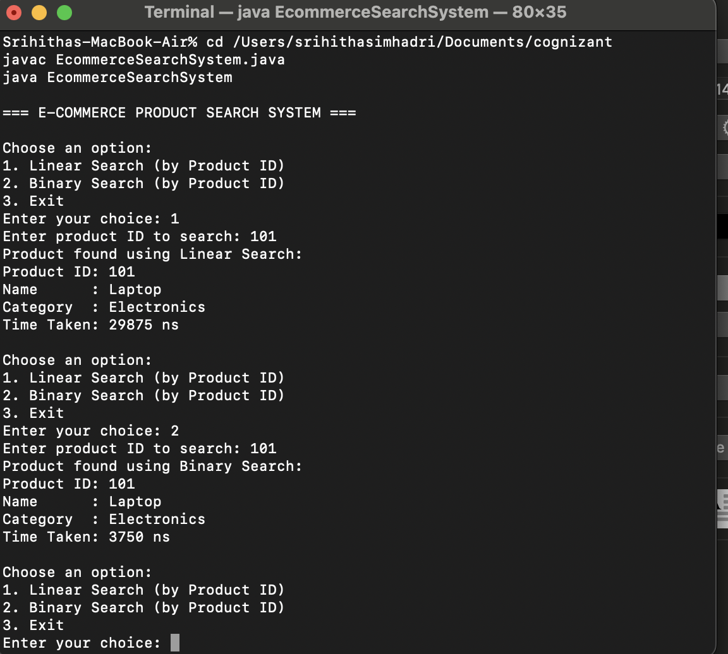
* As seen Binary Search (3750 ns) takes less time than Linear Search (29875 ns).
* Hence Binary Search is more preferable for E-commerce Platform.